

Visualizing Sustainability: A Cognos-Based Analysis Of Global Trends (2000-2023)

# 1 INTRODUCTION

1.1 Overview

The Sustainable Development Report (SDR) reviews progress made each year on the Sustainable Development Goals since their adoption by the 193 UN Member States in 2015. At the halfway mark to 2030, the Sustainable Development Report 2023 takes stock of progress made and discusses priorities to restore and accelerate SDG progress. Published on the eve of the 2023 Paris Summit for a New Global Financial Pact, this year’s edition focuses specifically on the need to scale up development finance and to reform the global financial architecture to support the SDGs.

1.2 Purpose

# The Sustainable Development Report (SDR) reviews progress made each year on the Sustainable Development Goals since their adoption by the 193 UN Member States in 2015. At the halfway mark to 2030, the Sustainable Development Report 2023 takes stock of progress made and discusses priorities to restore and accelerate SDG progress. Published on the eve of the 2023 Paris Summit for a New Global Financial Pact, this year’s edition focuses specifically on the need to scale up development finance and to reform the global financial architecture to support the SDGs

# 2 LITERATURE SURVEY

# A literature survey on the Sustainable Development Report 2023 dataset reveals a growing body of research and analysis centered around sustainability and the progress of countries toward achieving the United Nations' Sustainable Development Goals (SDGs). Scholars, policymakers, and organizations have recognized the significance of this dataset in assessing and advancing sustainability efforts on a global scale.he dataset has become a critical resource for policymakers, guiding the development and adjustment of policies and strategies to address specific SDGs. It assists in identifying areas requiring improvement and highlighting successful strategies.Some studies critically evaluate the dataset itself, discussing data accuracy, sources, and limitations. Researchers emphasize the importance of transparent and reliable data for meaningful sustainability assessments.

# 3 THEORITICAL ANALYSIS

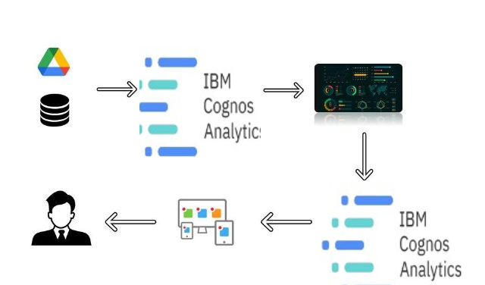

1. **RESULT**

**sdg_index_score and goal_1_score by goal_1_score**

**Analysis On Overall Sustainability On No Poverty**

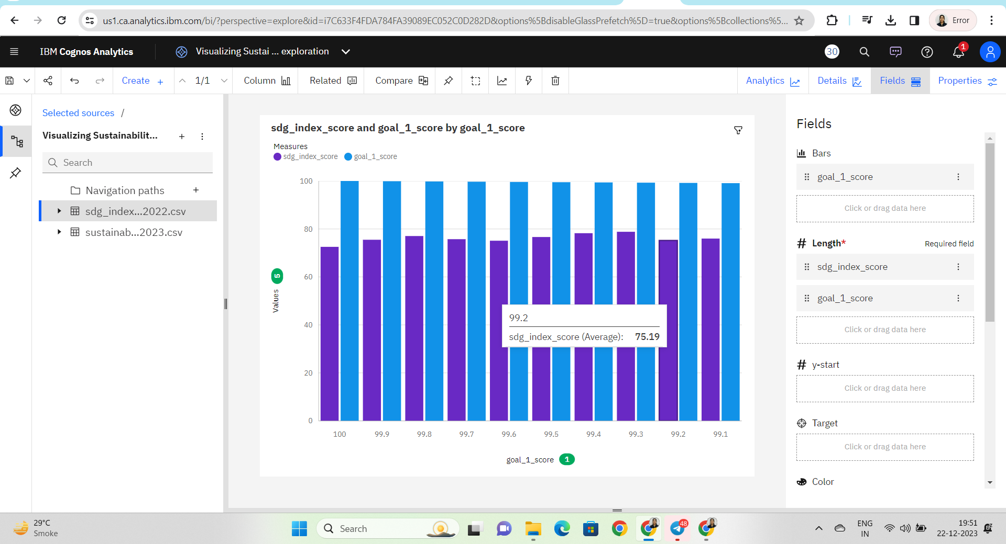

**Analysis overall sustainability on Quality Education**

**goal_4_score and goal_14_score by country**

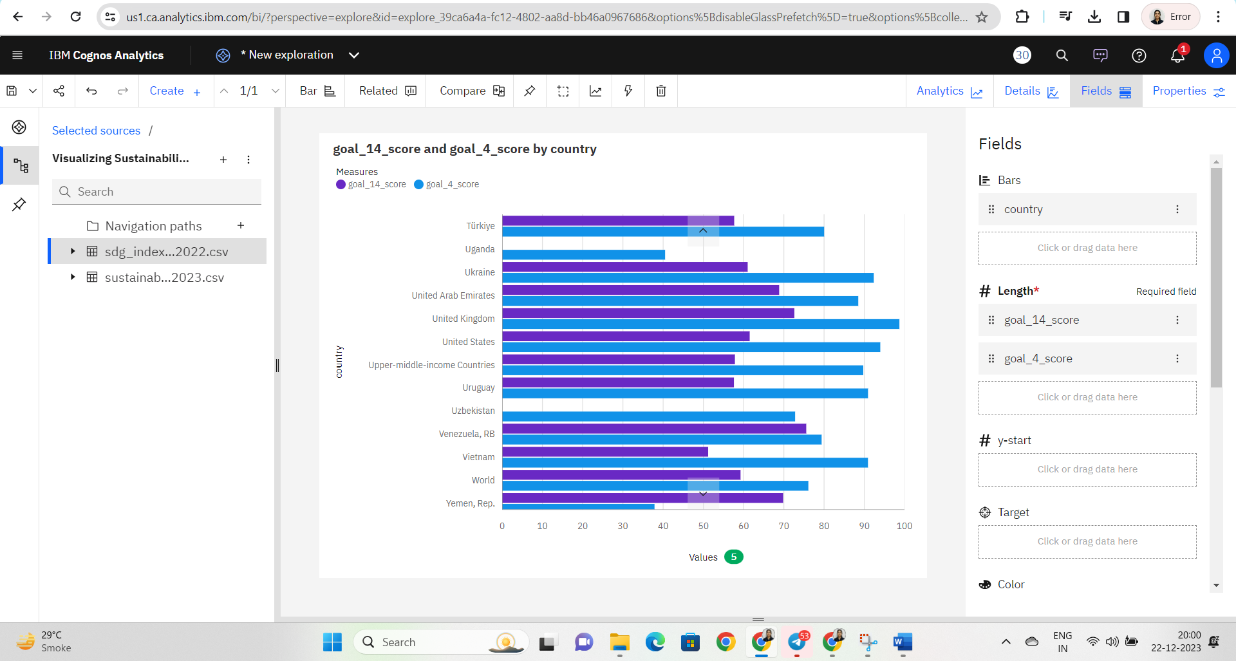

### Analysis On Overall Sustainability Life Below Water

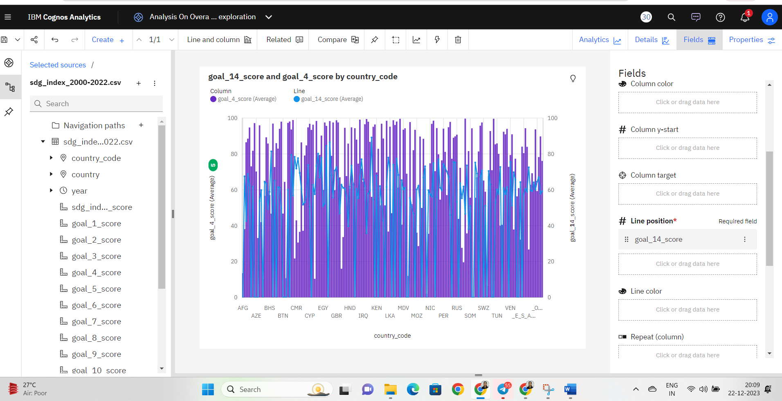

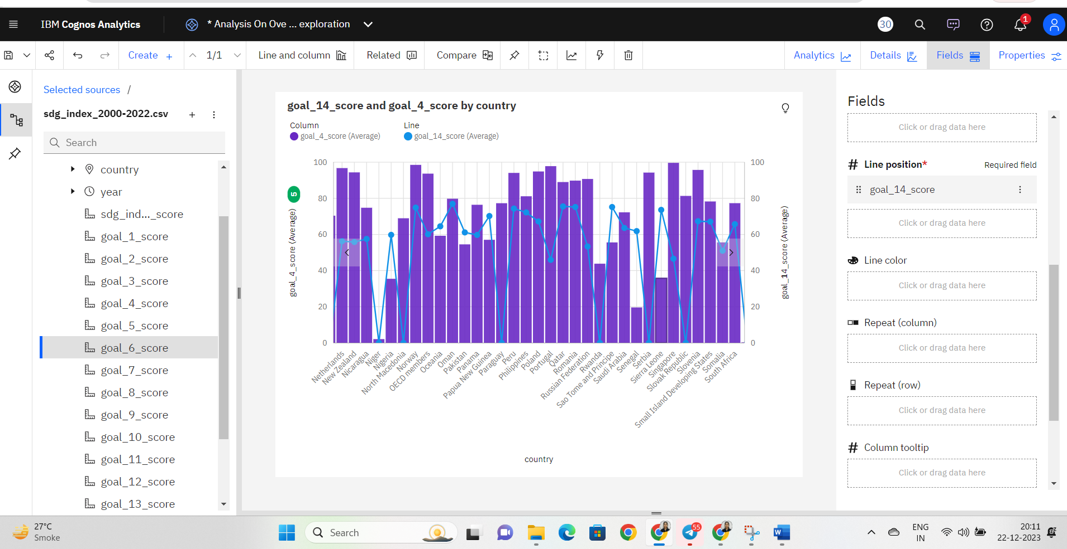

### Analysis On Overall Sustainability Partnerships For The Goals

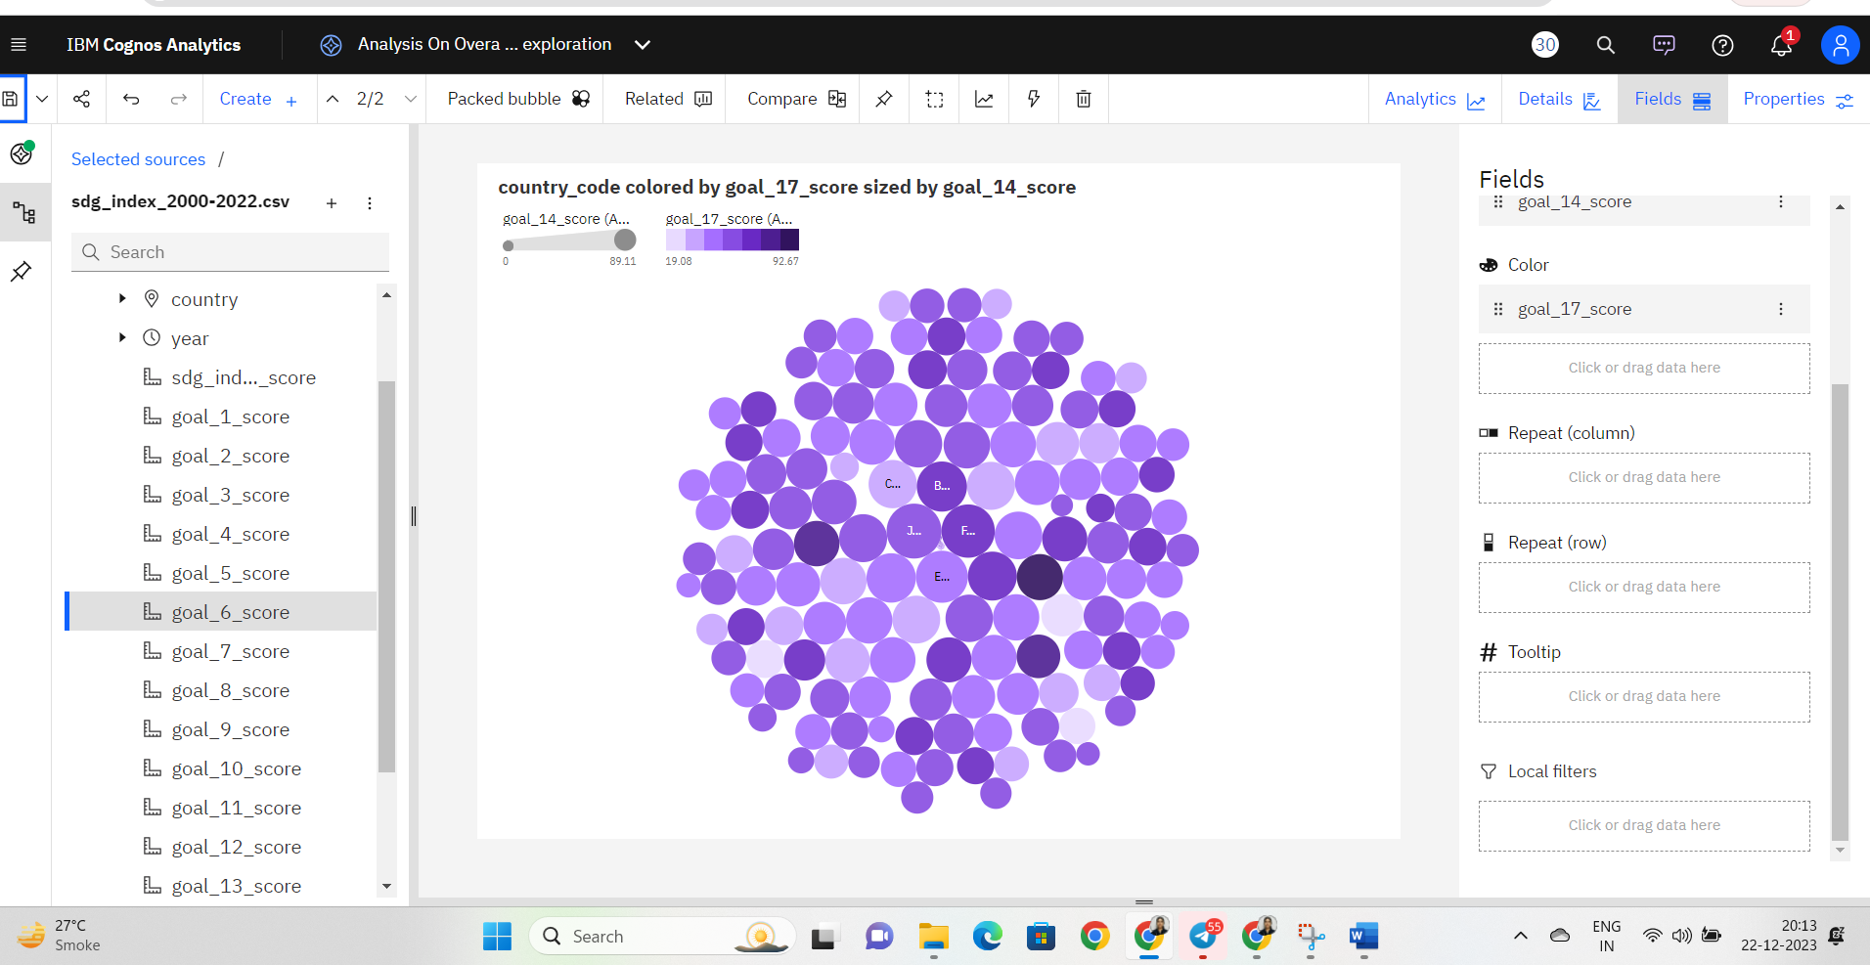

### Analysis On Overall Sustainability Reduced Inequalities

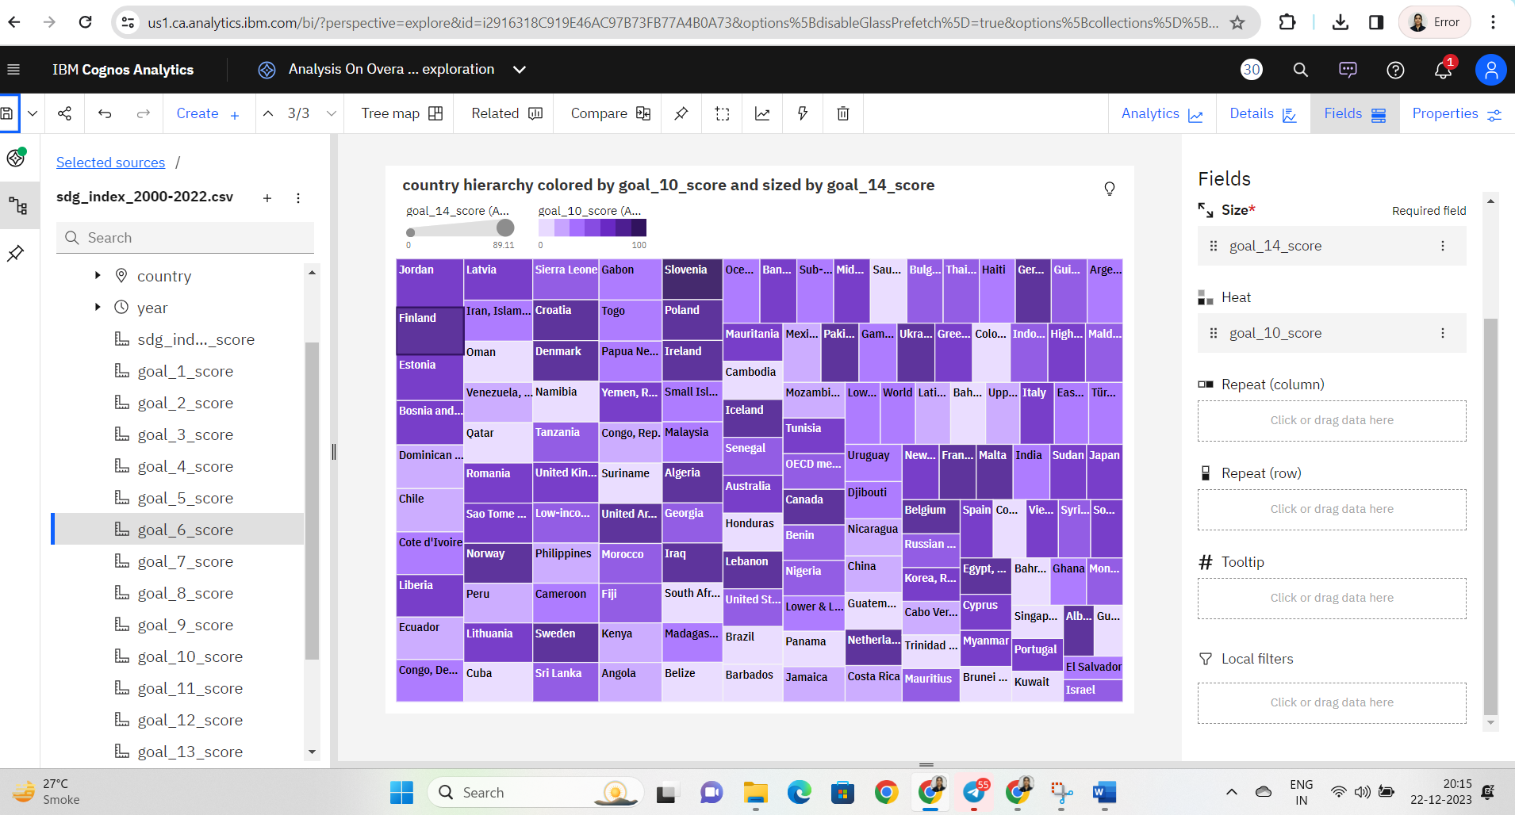

### Analysis On Overall Sustainability Industry, Innovation And Infrastructure

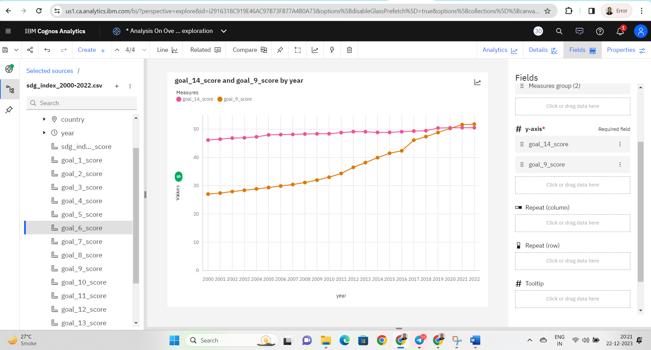

### Analysis On Overall Sustainability Life On Land

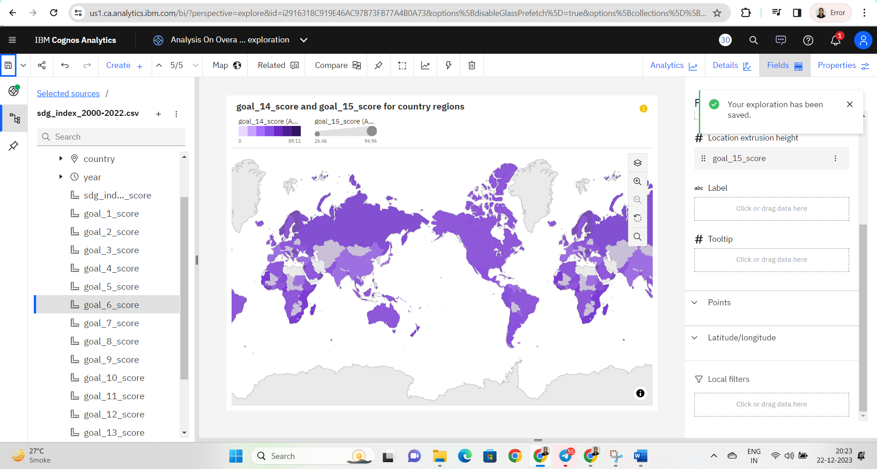

### Dashboard

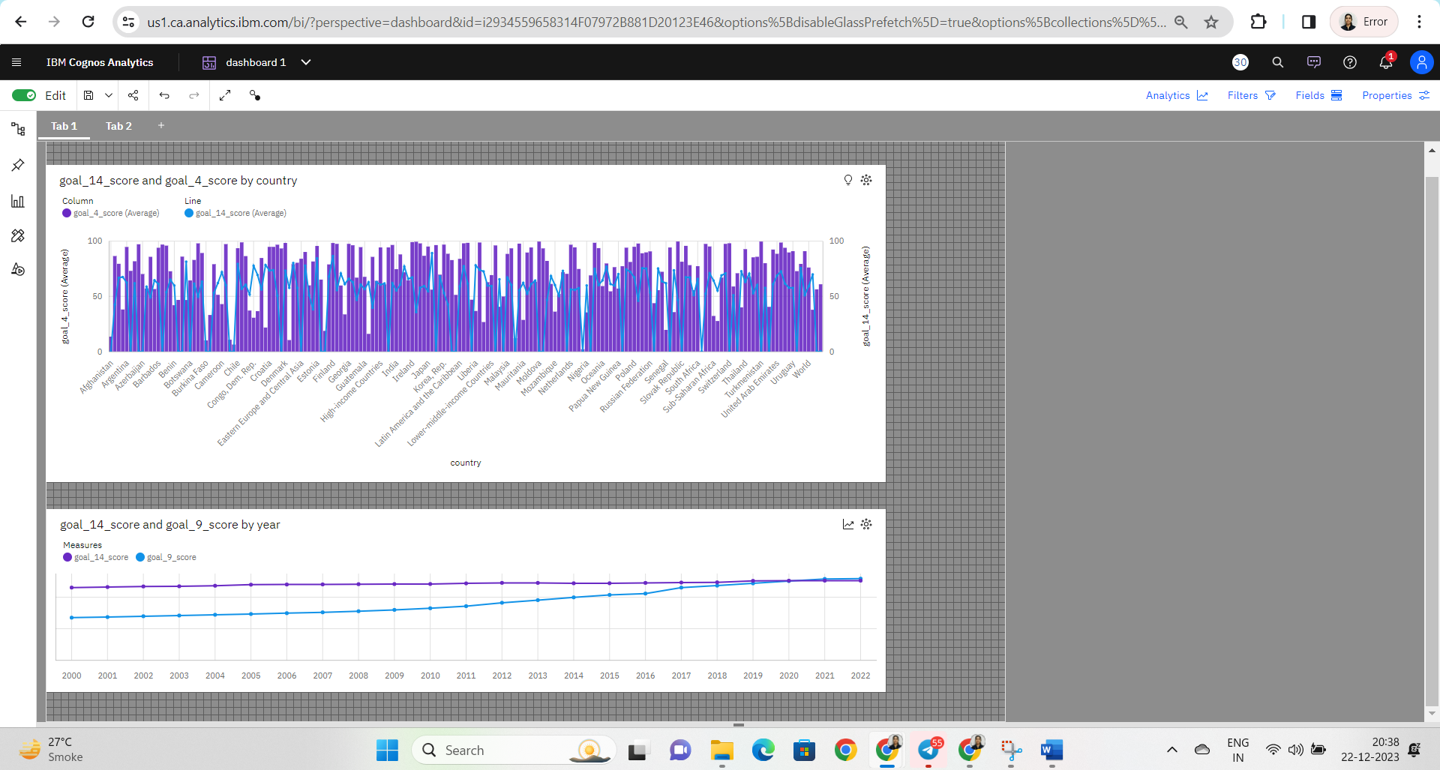

**Dashboard 2**

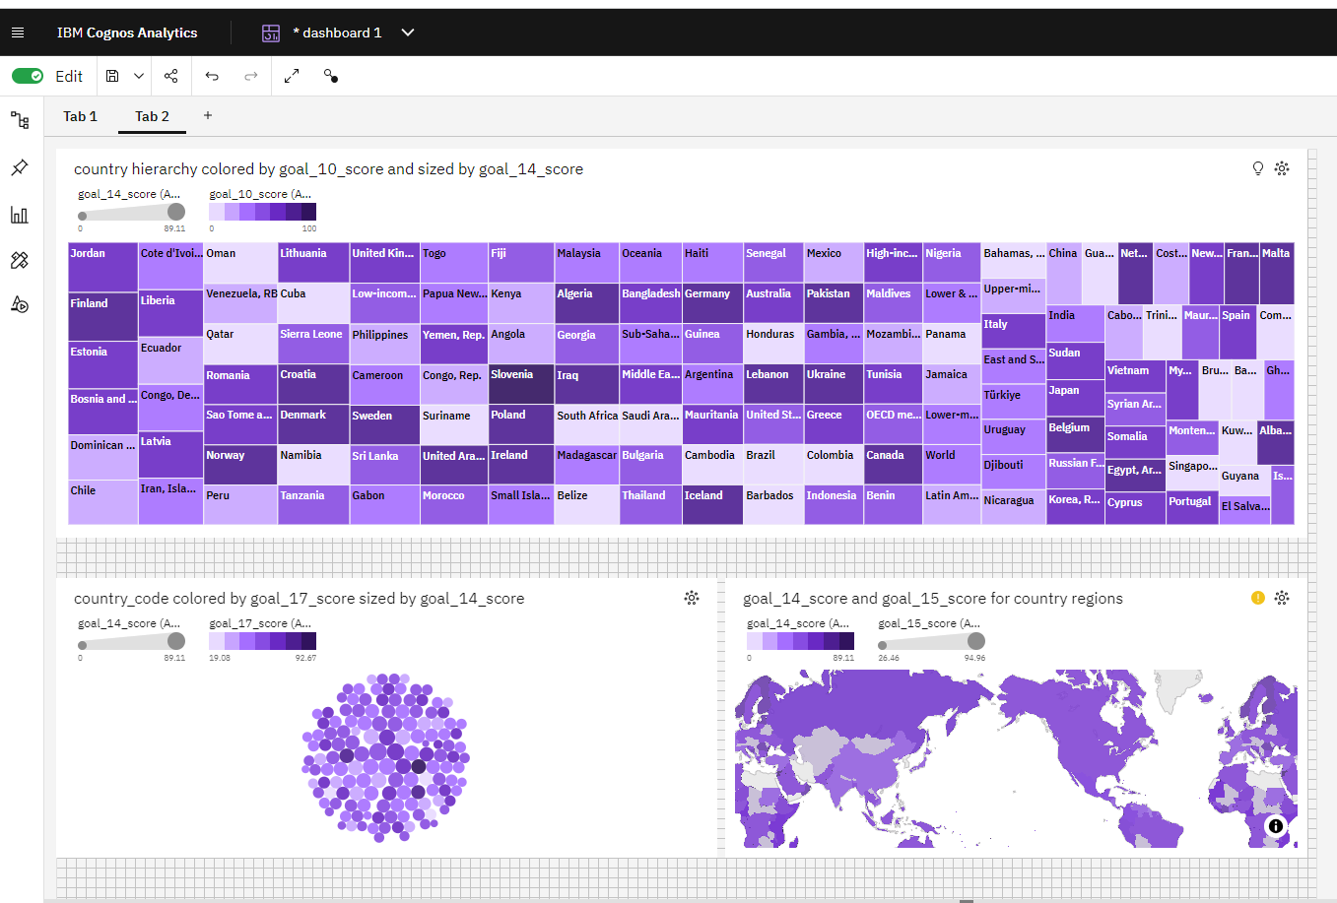

### No Of Scenes Of Story

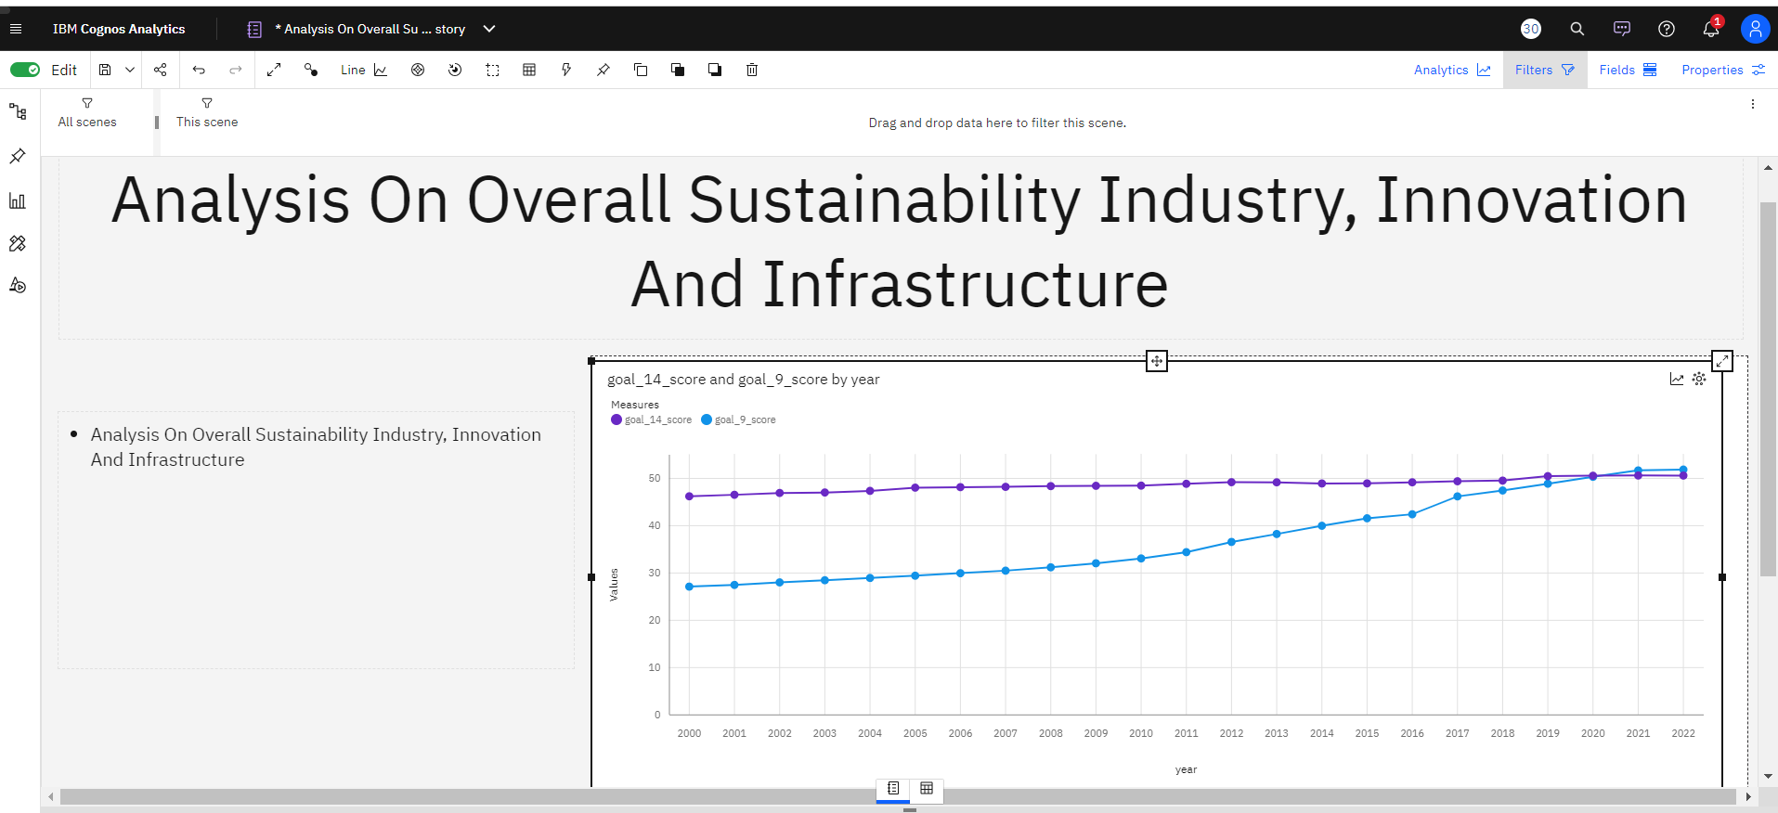

* Analysis On Overall Sustainability Life Below Water

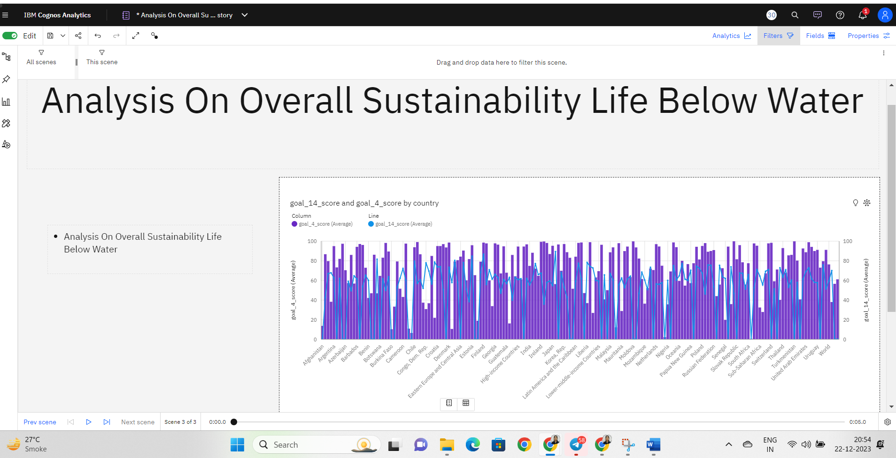

### Creating A Report

Activity 1: Creating a report

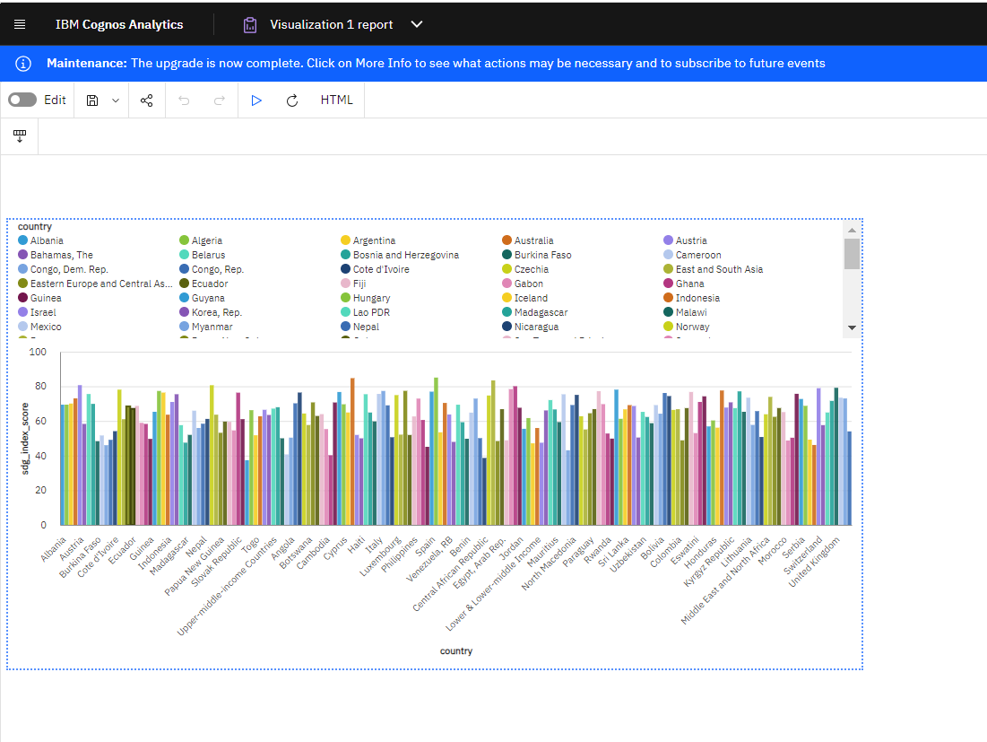

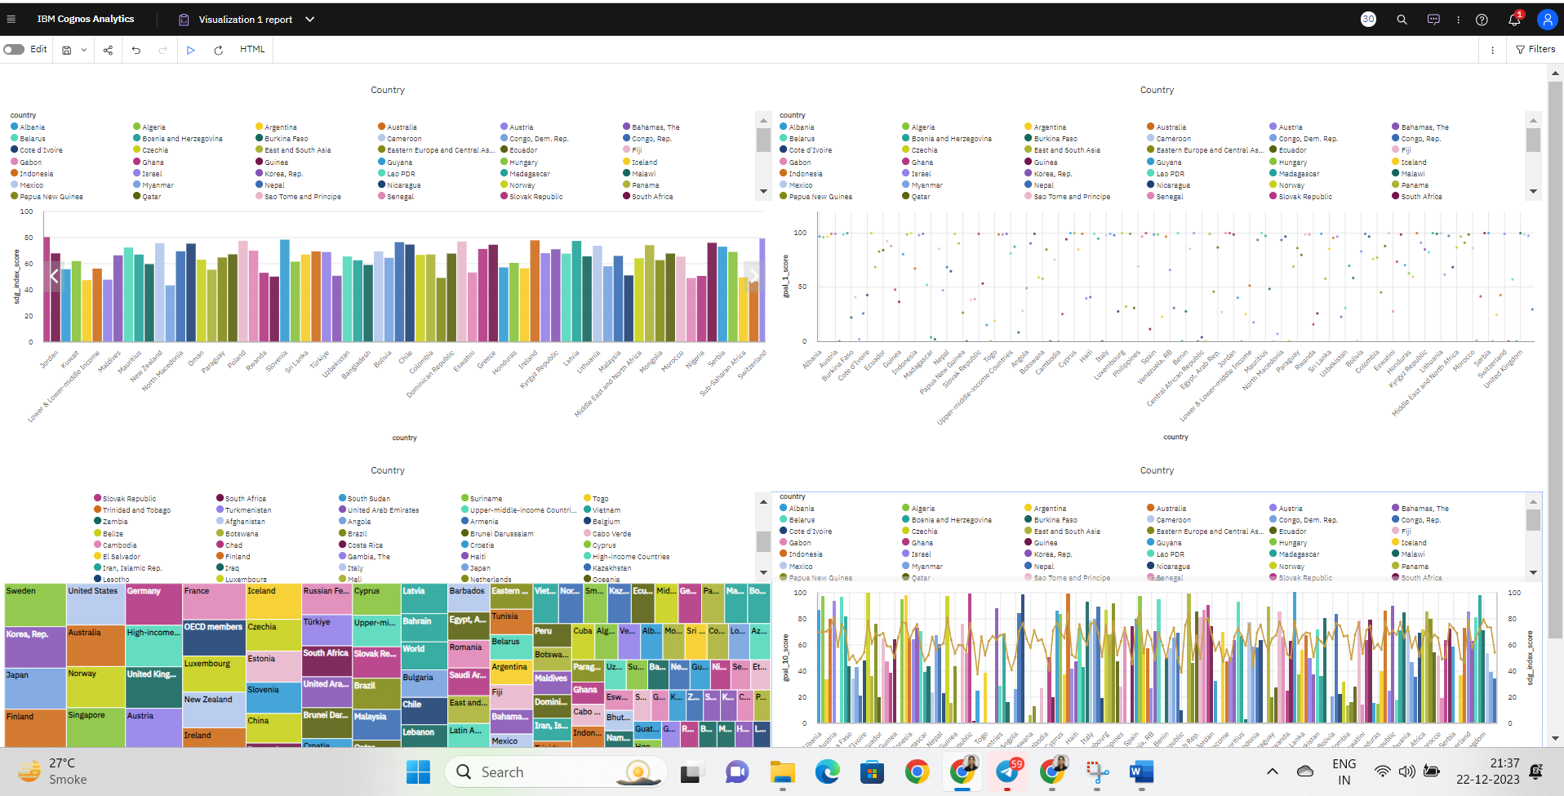

### Performance Testing

**Activity 1: Utilization of Data Filters**

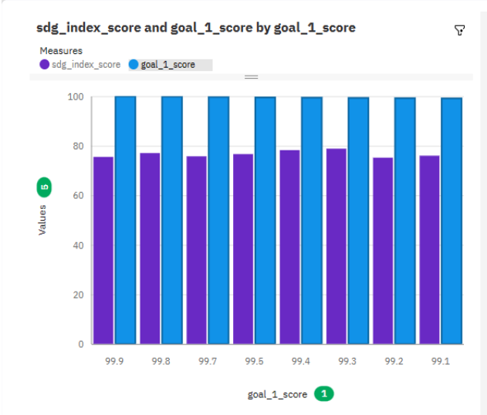

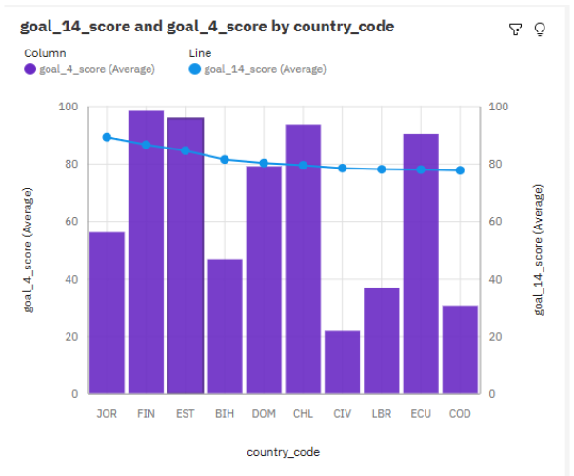

### No Of Calculation Fields

### 

### Dashboard And Story Embed With UI With Flask

**Activity 1: Dashboard and Story embed with UI With Flask**

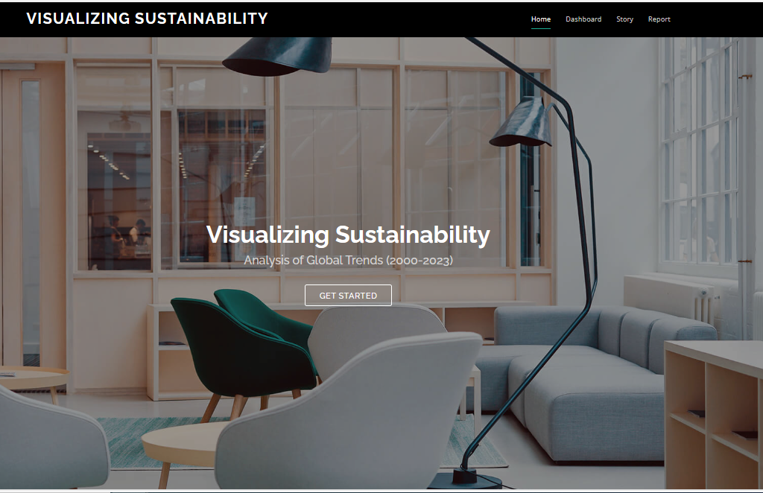





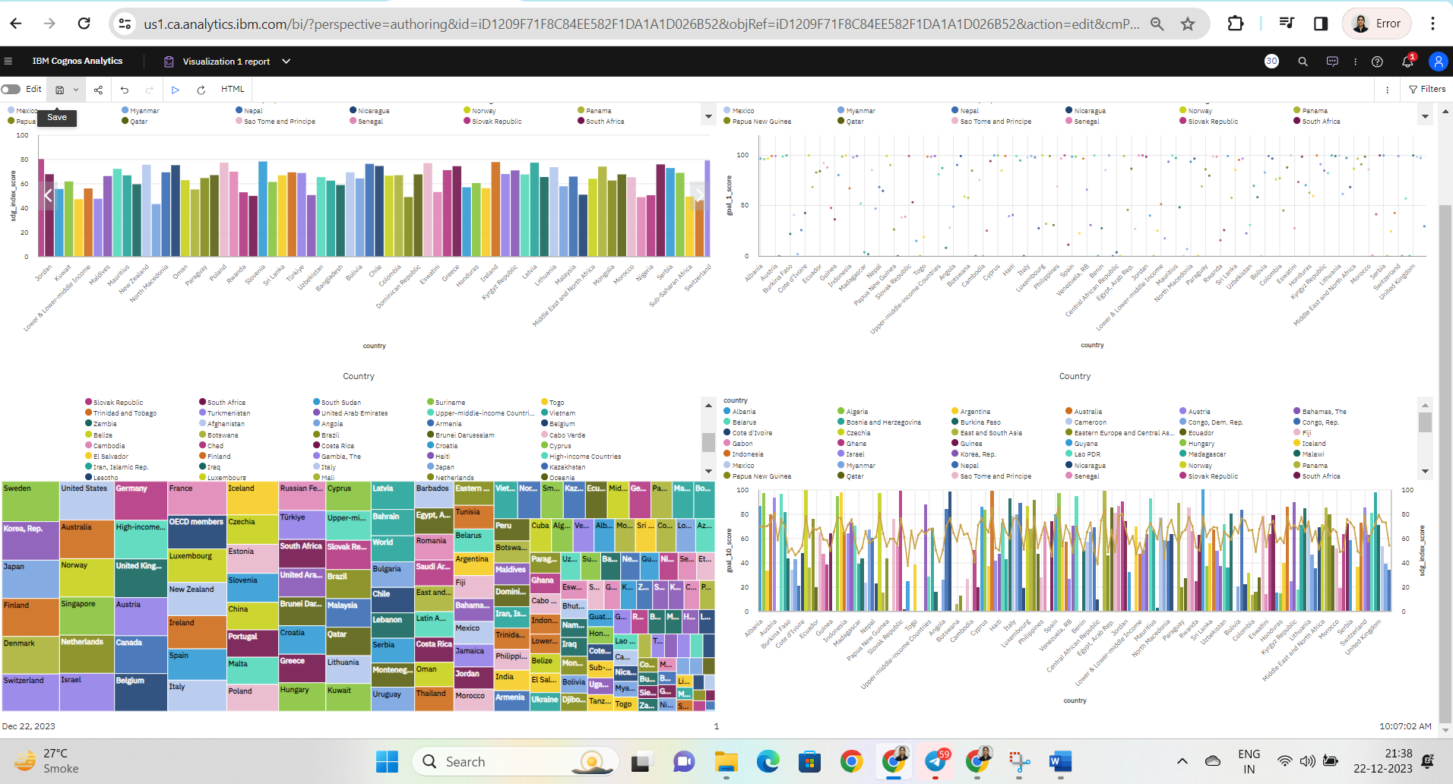

# APPENDIX

A. Source Code

Attach the code for the solution built.

**REPORT VISUALIZATION**

<iframe src="https://us1.ca.analytics.ibm.com/bi/?pathRef=.my_folders%2FVisualizing%2BSustainability%2FVisualization%2B1%2Breport&amp;closeWindowOnLastView=true&amp;ui_appbar=false&amp;ui_navbar=false&amp;shareMode=embedded&amp;action=run&amp;format=HTML&amp;prompt=false" width="320" height="200" frameborder="0" gesture="media" allow="encrypted-media" allowfullscreen=""></iframe>

**REPORT DASHBOARD**

<iframe src="https://us1.ca.analytics.ibm.com/bi/?perspective=dashboard&amp;pathRef=.my_folders%2FVisualizing%2BSustainability%2Fdashboard%2B1&amp;closeWindowOnLastView=true&amp;ui_appbar=false&amp;ui_navbar=false&amp;shareMode=embedded&amp;action=view&amp;mode=dashboard&amp;subView=model0000018c92098d4d_00000003" width="320" height="200" frameborder="0" gesture="media" allow="encrypted-media" allowfullscreen=""></iframe>